
KAY DEV
BUILDING YOUR DIGITAL PRESENCE

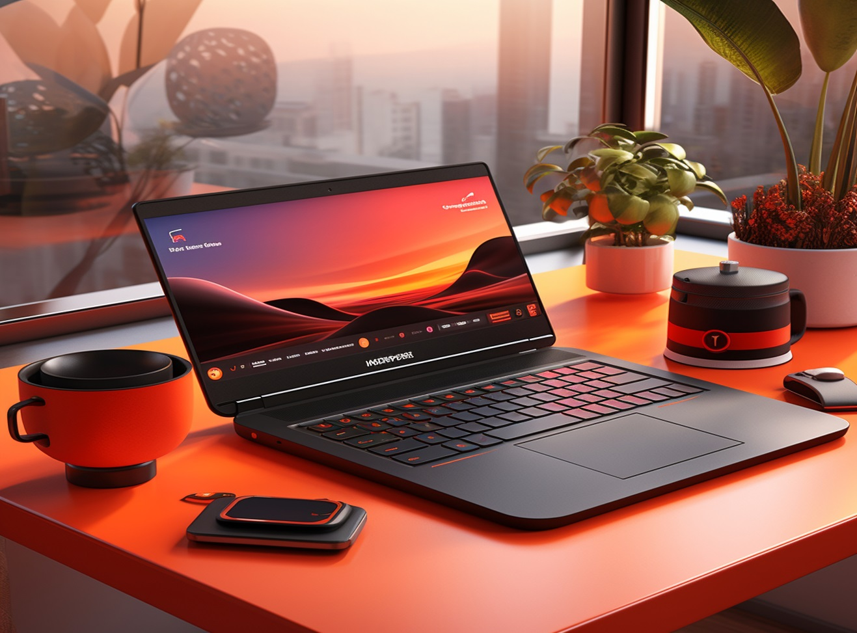
Contact Us
Phone: +233 534 329 262
Email: mailto:kennethamoah530@gmail.com
Welcome to Kay Dev
Your Partner in Website Development

At Kay Dev, we specialize in crafting custom websites that drive results. Our team of experts is dedicated to delivering high-quality solutions that meet your unique needs.




GRAPHIC DESIGN
We create custom logos, marketing materials, and branding solutions that establish a strong visual presence for your brand.

MOBILE APP
DEVELOPMENT
We develop custom and cross-platform mobile apps, tailored to fit your brand’s needs.
WEB DEVELOPMENT
We create custom, responsive, and mobile-friendly websites that reflect your brand and are delivered quickly.
Our Services

